

THE SUTTON MUNICIPAL CODE, 2022

Revised and Codified under the Authority of the Common Council of The Town of Sutton

Mayor:
Recorder:
Councilmembers:

Jon D. Hoover
None
Steven D. Facemire
Catherine Hoover
Laura Beth Atkins
Robyn Dolan
Jonathan M. Crum

ADOPTING ORDINANCE
AN ORDINANCE ADOPTING AND ENACTING A CODIFICATION AND REVISION OF THE ORDINANCES OF THE TOWN OF SUTTON, WEST VIRGINIA.
WHEREAS many of the ordinances of the Town of Sutton are obsolete, and
WHEREAS many of the other ordinances of the municipality are inconsistent with each other or are otherwise inadequate, and
WHEREAS the Common Council of the Town of Sutton has caused its ordinances of a general and permanent nature to be codified and revised and the same are embodied in a codification and revision known as "The Sutton Municipal Code, 2022",
NOW, THEREFORE, BE IT ORDAINED BY THE COMMON COUNCIL OF THE TOWN OF SUTTON, WEST VIRGINIAr THAT:
Section 1. The Common Council of the Town Of Sutton may exercise all powers conferred by Chapter 8 of the official code of West Virginia for the year 1931, and all other powers conferred by later acts of the regular and extra sessions of the West Virginia Legislature or by any other laws of said state, upon cities, towns, and villages incorporated without special charter.
Section 2. The ordinances of the municipality of a general and permanent nature as codified and revised in the following "chapters", namely "chapters" 1 to 11, both inclusive, are ordained as general ordinances and adopted as "The Sutton Municipal Code, 2022", hereinafter referred to as the "Town Ordinances".
Section 3. All ordinances of a general and permanent nature hereby except contained in the Town Ordinances as were amended in 2022 are hereby repealed frgm and after the effective date of said code, as hereinafter provided.
Section 4. The repeal provided for in the preceding section of this ordinance shall not affect any offense or act committed or done prior to the date of enactment hereof and any such offense or act may be prosecuted under the terms of such repealed ordinance as the said terms may have provided prior to the enactment hereof, or any penalty or forfeiture incurred, or any contract or right established or accruing before the effective date of the Town Ordinances; nor shall such repeal affect any ordinance or resolution promising or guaranteeing the payment of money for the municipality or authorizing the

issuance of any bonds of said municipality or any evidence of said municipality's indebtedness, or any contract or obligation assumed by said municipality; nor shall it affect any right or franchise conferred by any ordinance or resolution of the municipality on any person, firm, or corporation; nor shall it affect any prosecution, suit or other proceeding pending or any judgment rendered on or prior to the effective date of said code; nor shall it affect any ordinance annexing territory to the municipality; nor shall such repeal affect any ordinance not specifically repealed by these Town Ordinances.
Section 5. Insofar as the provisions of the Town Ordinances are the same as those of ordinances existing and in force at its effective date, said provisions shall be considered to be continuations thereof and not as new ordinances.
Section 6. Wherever in the Town Ordinances, including the codes and ordinances adopted by reference, any act is prohibited or is made or declared to be unlawful or an offense or a misdemeanor, or wherever in the Town Ordinances the doing of any act is required or the failure to do any act is declared to be unlawful, the violation of any such provision of the Town Ordinances shall, unless otherwise provided, be punishable by a fine of not more than five hundred dollars for each separate violation, provided, however, that the infliction of a fine under the provisions of this section shall not prevent the revocation of any permit or license or the taking of other punitive or remedial action where called for or permitted under the provisions of the Town Ordinances or other applicable law.
Section 7. Any printed copy of the Town Ordinances certified under the actual or facsimile signature of the Town Recorder shall be held to be a true and correct copy of such codification and may be read in evidence in the municipal court without further proof of the provisions contained therein.
Section 8. Each section of the Town Ordinances, including the codes and ordinances adopted by reference, is hereby declared to be separable and severable and the invalidity of any section, part, paragraph, sentence, phrase, or word in the Town Ordinances shall not affect the validity of any other part of said Ordinance#r and only any part declared to be invalid by a court of competent jurisdiction shall be deleted therefrom.
Section 9. Immediately upon adoption of the Town Ordinances they shall be reproduced in loose-leaf form as provided in Chapter 1, Section 311 of said code, and shall be

made available to town officers and to other persons who shall request and par for said ordinance book. One copy of the Town Ordinances as originally adopted and one copy of each amending ordinance adopted thereafter shall be mailed to the West Virginia Municipal League immediately after adoption.
Section 10. At least one copy of the Town Ordinances, maintained currently up to date, shall be kept available in the Recorder's Office for public use and inspection at all reasonable times.
Section 11. This ordinance shall take effect at 00:01 a.m.
JANUARY 3, 2023, the public welfare requiring it, and the Town Ordinances, including all the codes and ordinances therein adopted by reference, shall be effective on and after that date.
Ordained and enacted into an ordinance this 29th day of December 2022.
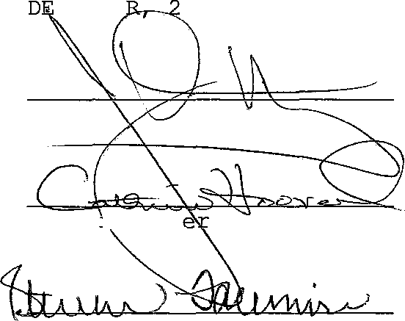

Mayor
Councilmember

Recorder
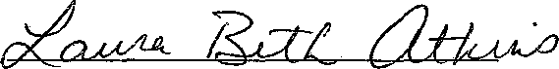
Councilmember

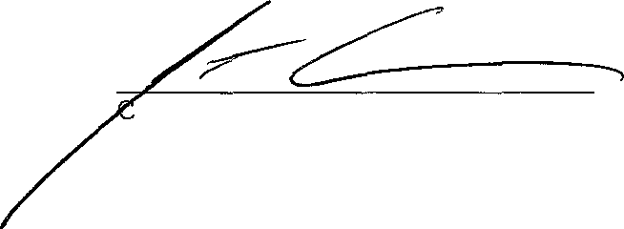
Councilmember

councilmember
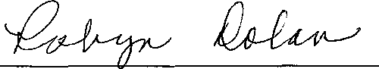
Councilmember

